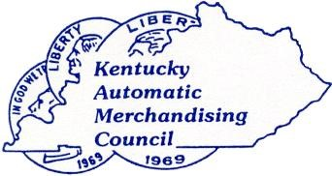
Serving the Vending, Coffee Service and Foodservice Industry in the Commonwealth of Kentucky
2026 MEMBERSHIP APPLICATION AND RENEWAL FORM

Company Contact _______________________
Address City _____________ State Zip______
Phone ________________________________
E-mail (s) _______________ (exclusively for KAMC use)
NAMA Member: Yes No____
OPTIONAL - Number of Vending Locations ___ Micro Market Locations____ Coffee Service Locations____
Annual Dues
Operator *****New OPERATOR Member Incentive Program – No Dues for 2026*****
1 to 3 employees (FT equivalents) $100_____ 4 and over $300_________
Multiple Branches $100 each__________
Supplier $350_______________
Voluntary Donation to ‘The Past Presidents Scholarship’ $_________
Voluntary Annual Meeting Sponsorship $
Total Due $ _______

Signature______________________________________Date________________

Please click on the link - https://forms.gle/fk4u6PSvuBAGTz9i9
Fill out the form and submit online and submit payment via www.kyvending.org
OR submit the form online and mail a check to KAMC
OR print the form, fill it out, mail the form and check to KAMC
KAMC c/o Kentucky Retail Federation
340 Democrat Dr.
Frankfort, KY 40601
Thank you for being a member!

